 |  |  | Linking Soil and Watershed Health to In-Field and Edge-of-Field Water Management  Convening Event  January 23 – January 24, 2020 | Morgantown, WV  Erickson Alumni Center, West Virginia University
  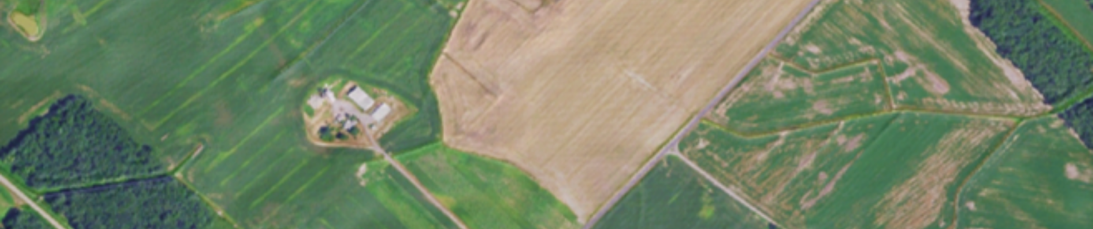
  Thank You!
  For more information please contact
  Kathy Boomer, Scientific Program Director
  kboomer@foundationfar.org
  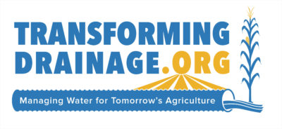
  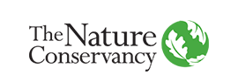
  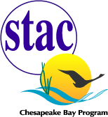
  
  
  Made Possible By

Christopher Craft  Page 2
  SPEAKERS
  Sally Rockey
   | The Foundation for Food and Agriculture Research  Dr. Sally Rockey became the inaugural Executive Director of the Foundation for Food and Agriculture Research in September 2015. Prior to this role, Dr. Rockey was an award-winning leader in Federal research. Dr. Rockey received her Ph.D. in Entomology from the Ohio State University and did postgraduate work at University of Wisconsin prior to joining the government.
    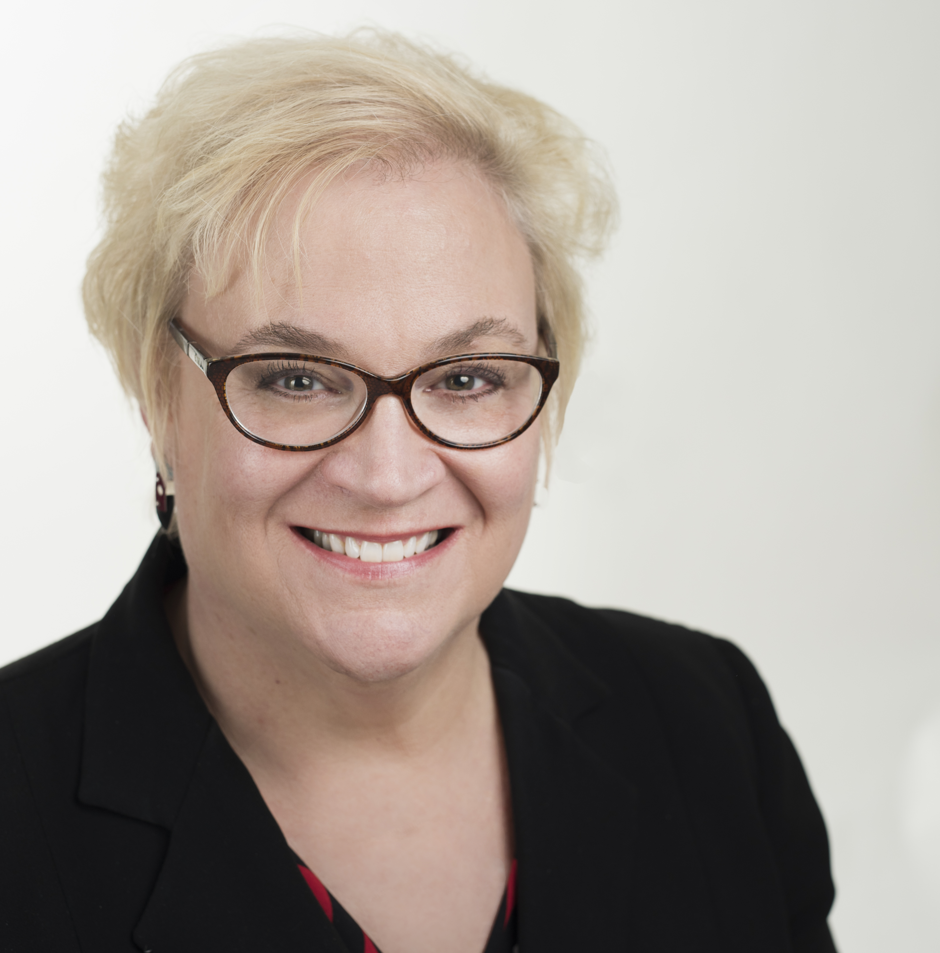
  - Plenary -
  Chandra Madramootoo
   | Current research challenges in drainage management.  Chandra is a Professor of Bioresource Engineering, and Director of the Water Innovation Lab at McGill University. He is also a Visiting Scholar in water and food security at MIT. His areas of expertise include water management, irrigation, drainage, agricultural research, international agriculture development, hydrology and water quality of surface and subsurface drained fields, development of innovative technologies to predict crop water requirements, and impacts of water management practices on greenhouse gas emissions.Chandra.madramootoo@mcgill.ca
    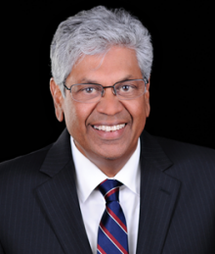
  - Plenary -
   | Soil health and soil function: A wetland ecologist’s perspective.  Chris, a professional wetland scientist, has been with the O'Neill School at Indiana University since 1999 and is the Duey Professor of Rural Land Policy. For the past 30 years, Craft has studied the effects of climate change, eutrophication, and other human activities on estuarine and freshwater wetlands and the restoration of those ecosystems. ccraft@indiana.edu
    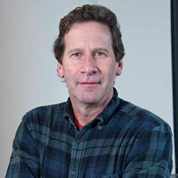
  Notes

Participants  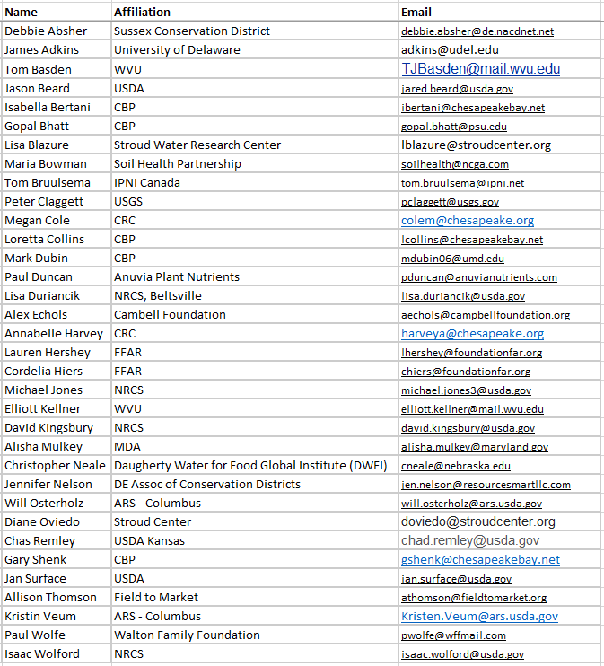 |  |  | Panel I – Soil Health State of the Science  Rattan Lal  Ken Staver  Mark Tomer
  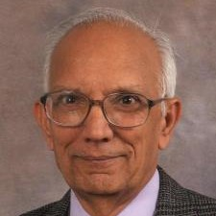 | Managing soil physical health.  Rattan is a Distinguished University Professor of Soil Science and Director of the Carbon Management and Sequestration Center at The Ohio State University, and an Adjunct Professor of University of Iceland. He received a B.S. from Punjab Agricultural University, Ludhiana, India (1963); M.S. from Indian Agricultural Research Institute, New Delhi, India (1965); and Ph.D. from the Ohio State University, Columbus, Ohio (1968) lal.1@osu.edu.
  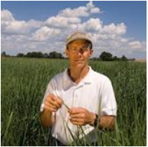 | Optimizing soil and water quality.  Ken’s primary research interest is the development of agricultural production systems that maximize nutrient and energy use efficiency and minimize environmental degradation at the field and system level. He has worked at the Wye Research and Education Center since 1984 focusing initially on nutrient transport patterns in Coastal Plain watersheds and the development of practices that reduce nutrient losses from cropland at the field level. kstaver@umd.edu
  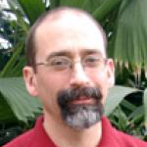 | Connecting soil health and watershed health.  Mark is a Research Soil Scientist at the USDA-ARS National Laboratory for Agriculture and the Environment. He has conducted watershed assessment studies under USDA’s Conservation Effects Assessment Project (CEAP) to determine the effects of agricultural conservation practices on water quality in fields and watersheds. mark.tomer@usda.gov

Panel II – Soil Health, Soil Physics, and Hydrology in the Vadose Zone  Ryan Stewart  Brian Badgley  Michael Castellano
   | Hydrologic implications of using cover crops to build soil health.  Ryan is an Assistant Professor of in Crop and Soil Environmental Sciences at Virginia Tech. His research focuses on quantifying and scaling interactions between water, soil, and plant communities. This includes a combination of field work, laboratory analysis, and development of modeling frameworks. rds@vt.edu
    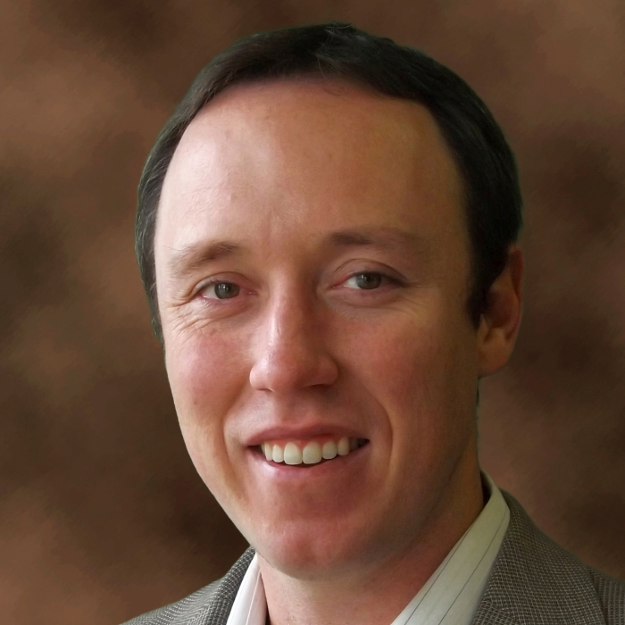
  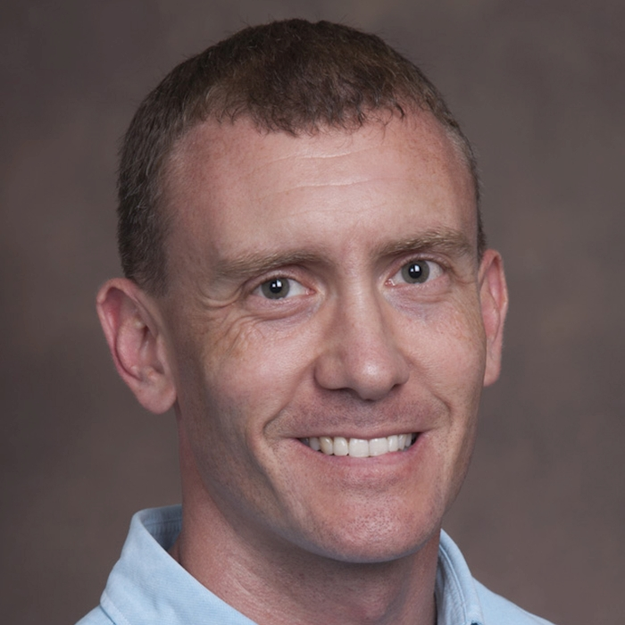 | Evaluating soil biology: Where do we stand?  Brian’s research focuses on environmental microbiology and microbial ecology. He is interested in the ecological roles of microbial populations and communities in the environment, and particularly how changes in the microbiome affect biogeochemical processes and soil and water quality. One of his current projects looks at patterns in microbial diversity and community structure in agricultural and forest soils, as well as other habitats. badgley@vt.edu
  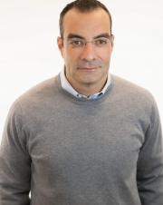 | Agricultural management practices that improve soil health, but reduce soil organic matter.  Mike’s research focuses on biogeochemical cycling and transport within the soil as it extends to the atmosphere and subsoil. His ultimate objective is to maximize sustainable productivity of agricultural systems. Mike is Professor of Agronomy and William T. Frankenberger Professor of Soil Science. He participates in Environmental Science, Sustainable Agriculture, and Ecology & Evolutionary Biology interdepartmental graduate degree programs. castelmj@iastate.edu
  Jason Hubbart
   | Jason’s research interests lie in the integrated fields of physical hydrology, water resources, water quality, biogeochemistry, environmental biophysics, and ecology. He is keenly interested in the interactions of biota and hydrologic disturbance, climate change, droughts, flooding, biogeochemistry and issues related to conservation and sustainability of fresh water resources. gali@uoguelph.ca
    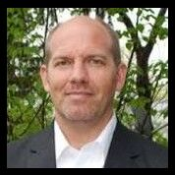
  Amy Jacobs
  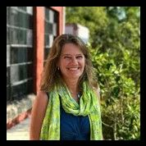 | Amy joined the Maryland/DC chapter in 2011 and leads efforts to improve water quality in agricultural landscapes across the Chesapeake Bay watershed, both through large-scale wetland and floodplain restoration projects as well as working with farmers and agribusinesses to implement best practices to keep nutrients on fields and out of waterways. ajacobs@tnc.org
  Lindsay Thompson
  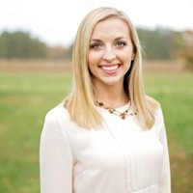 | Lindsay is a graduate of Washington College with a Bachelor’s in Political Science and earned her Master’s Degree from the University of Maryland in Public Policy. Her passion for agriculture and policy led her to her current position as a Policy and Programs Assistant at Maryland Agricultural Associates. Currently, Lindsay conducts government, board and public relations for the Maryland Grain Producers Association and MidAtlantic Certified Crop Advisers Program as well as Assist in the administration of the Maryland Grain Check Off Program through the Maryland Grain Producers Utilization Board. lindasay.mdag@gmail.com
 |  |  |  |  |  |  |  |  | 7
ADDITIONAL STEERING COMMITTEE MEMBERS  Matthew Erhardt |  |  |  |  |  |  | 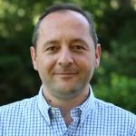 |  | Sotirios Archontoulis  Ray Bryant
  Chris Brosch
  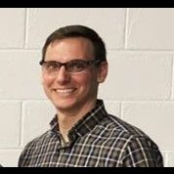 | Chris serves as Program Administrator, Nutrient Management, Delaware Department of Agriculture. He administers the voluntary Nutrient Management Program, which helps to generate and disperse agricultural nutrients in a responsible and sustainable way. Chris.Brosch@delaware.gov
  Amy Collick
  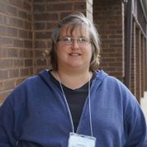 | Amy is an Assistant Research Professor at the University of Maryland, Eastern Shore. Her work is focused on nutrient transport and watershed modeling; water quality monitoring; watershed modeling; soil health initiatives for research and education. ascollick@umes.edu
  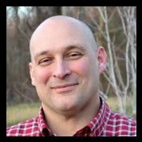 | Matthew is the Director of Watershed Restoraction at the Stroud Water Research Center. His work is focused primarily on water quality, watershed restoration, agricultural conservation and preservation, and the associated policy and implementation issues. mehrhart@stroudcenter.org
  Modeling shallow water table impacts on productivity and soil health in the US Corn Belt.
  Sotirios is an assistant professor of integrated cropping systems at the Department of Agronomy. His main research interests involve understanding complex Genotype by Management by Environment interactions and modeling various components of the soil-plant-atmosphere continuum. Sotirios’ overall goal is to investigate practices that can increase the efficiency of system by means of increasing crop yields and simultaneously decreasing inputs or losses such as water and nitrogen. sarchont@iastate.edu
  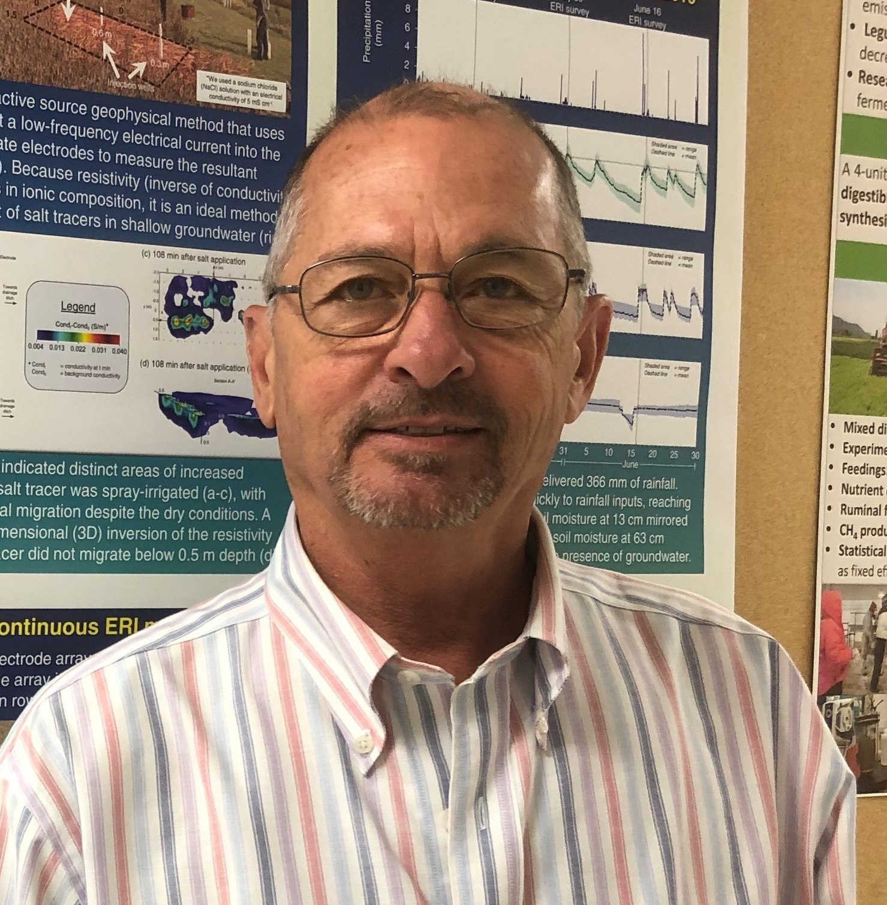 | Drainage water management: For what purpose.  Ray is a Research Soil Scientist at the USDA Agricultural Research Service’s Pasture Systems and Watershed Management Research Unit located on Penn State’s University Park campus. He serves as the Lead Scientist for the ARS Water Quality project and conducts research in Pennsylvania and on Maryland’s Eastern Shore of the Chesapeake Bay. Ray led development of NRCS Conservation Practice 333: “Amending soils with gypsum products,” developed the original concept and design for the gypsum curtain and has conducted research on phosphorus sorption systems and denitrifying bioreactors. ray.bryant@usda.gov
  Panel III – Impacts of Drainage Water on In-field Soil Conditions and Watershed Hydrology
  Eileen Kladivko
  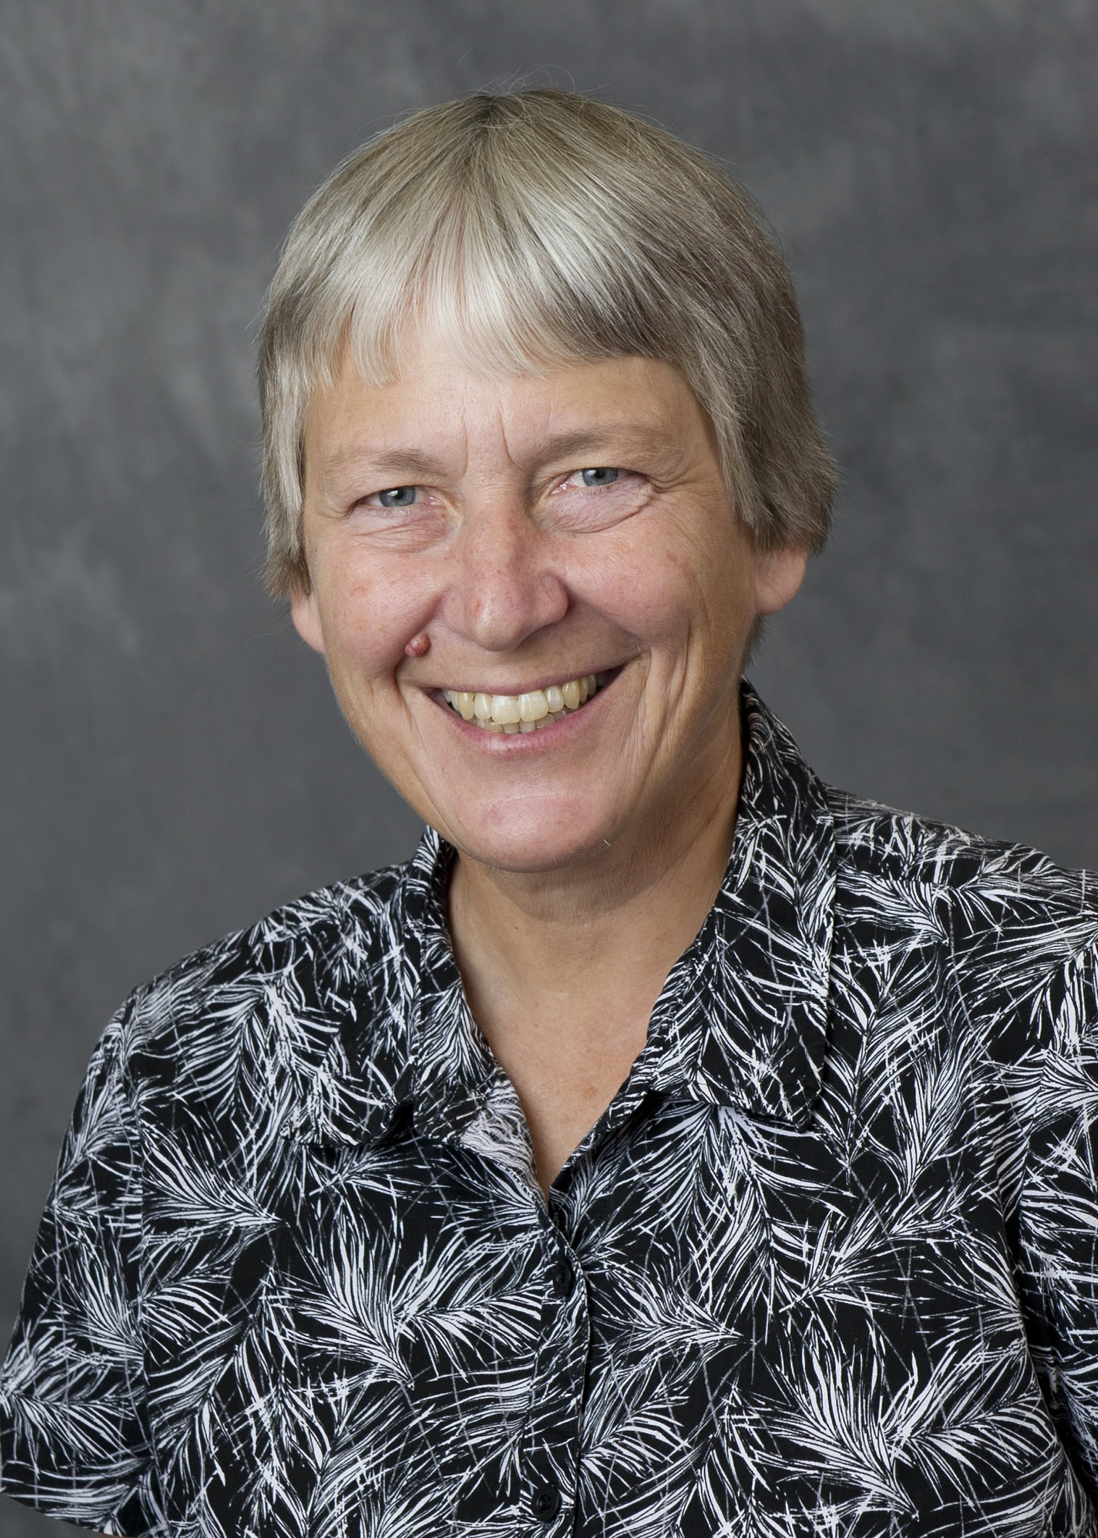 | Drainage intensity effects on water/nitrate flow and crop growth.  Eileen is a Professor of Agronomy at Purdue University, where she teaches and does research in soil physics, soil biology, and soil management. Her overall research focus is identifying soil management systems that improve environmental quality and promote agricultural sustainability. Specific research areas have included tile drainage and water quality; the interactions of earthworms, soil management, and soil physical properties; conservation tillage and cover crops for soil quality improvement; and preferential flow of chemicals through soils. kladivko@purdue.edu
  Keith Shilling
   | Water table fluctuations in tiled glacial landscapes.  Keith is a State Geologist and Research Scientist for the Iowa Geological Survey with research interests in hydrology, surface and groundwater interact, and land use/land cover change. Schilling has three decades of experience as a geologist in Iowa and serves as an adjunct assistant professor in the UI Department of Earth and Environmental Sciences. Keith-Schilling@uiowa.edu
    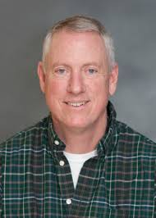
  Genevieve Ali
  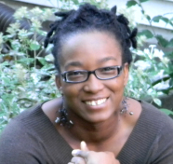 | Where do we need water table management? Using hydrologic connectivity as a screening tool.  Genevieve’s main areas of expertise are watershed hydrology (surface and shallow subsurface processes) and hydrological modelling, with a strong focus on watershed connectivity (water, chemical, sediment, biota). She especially focuses on the use of water storage thresholds, geochemical and isotopic tracers and topographically-derived indices to approximate the timing of connectivity. gali@uoguelph.ca
 | Chandra Madramootoo  Donald Rosenberry, Ph.D.  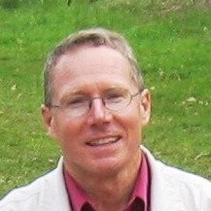  Potential hydrogeological controls on soil health and cropland productivity  Don is a research hydrologist with the Earth Surface Processes Division specializing in wetland hydrology, water budgets of lakes and wetlands, and hyporheic processes. His research is focused at the sediment-water interface with an emphasis on understanding processes that control exchanges between groundwater and surface water. Don is the coordinator of the Shingobee Headwaters Aquatic Ecosystem Project where scientists from USGS and academia work together to study physical, chemical, and biological processes of lakes, wetlands, and streams at a small-watershed scale. rosenber@usgs.gov  Panel V – Innovative Drainage Practices to Manage Shallow Water Tables  Jane Frankenberger |  |  |  |  |  |  | Laura Johnson  Kathy Boomer
  Panel IV – Reality Checks: Understanding Financial Implications and Other Concerns
  Steven Mirsky
  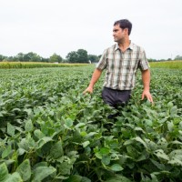 | Operationalizing soil health through on-farm research networks.  Steve…
  Samual Zipper
  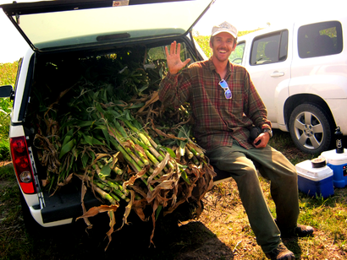 | Crop yield response to water table depth, soil texture, and weather variability.  Sam is a groundwater hydrologist within the Kansas Geological Survey, as a part of the University of Kansas. His expertise is in monitoring and modeling the movement of water and energy at the land surface and subsurface, including both saturated and unsaturated flow. Sam uses an interdisciplinary toolbox integrating field observations, process-based numerical modeling, and geospatial data science. samzipper@ku.edu
  Impact of water management and field management on greenhouse gas emissions.
  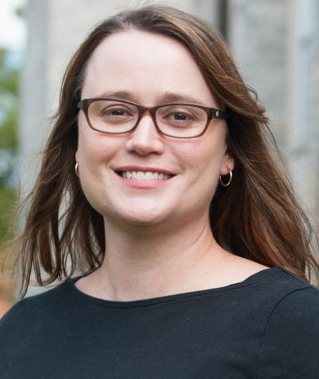 | Linking watershed health to agricultural practices.  Laura is director of the National Center for Water Quality Research at Heidelberg University where she works on watershed sediment and nutrient export. Prior to joining the NCWQR in 2013, Laura received her Ph.D. from the University of Notre Dame in 2008 and was a postdoc at Indiana University in Bloomington. Aside from working with the long-term Heidelberg dataset, her recent research also focuses on examining the influence of agricultural nutrient management on nutrient export, identifying sources of nutrients within watersheds, and contributing to the seasonal harmful algal bloom forecast for western Lake Erie. ljohnson@heidelberg.edu
  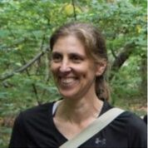 | Regional assessment of climate change effects on field conditions throughout a watershed.  Kathy recently joined the Foundation for Food and Agriculture Research, as a Scientific Program Director for the Sustainable Water Management Challenge Area. Previously, she served as Lead Watershed Scientist for the Nature Conservancy Chesapeake Bay project. Dr. Boomer continues to serve on the USEPA Chesapeake Bay Program’s Scientific Technical Advisory Committee (CBP STAC) providing expertise in landscape modeling, watershed research, and decision science. Kboomer@foundationfar.org
 | - Plenary -  Donald Rosenberry, Ph.D.  Potential hydrogeological controls on soil health and cropland productivity.  Don is a research hydrologist with the Earth Surface Processes Division specializing in wetland hydrology, water budgets of lakes and wetlands, and hyporheic processes. His research is focused at the sediment-water interface with an emphasis on understanding processes that control exchanges between groundwater and surface water. Don is the coordinator of the Shingobee Headwaters Aquatic Ecosystem Project where scientists from USGS and academia work together to study physical, chemical, and biological processes of lakes, wetlands, and streams at a small-watershed scale. rosenber@usgs.gov  Panel V – Innovative Drainage Practices to Manage Shallow Water Tables  Jane Frankenberger |  |  |  |  |  |  | Richard Cooke  Francois Birgand  Jeff Strock
   | Does drainage water management affect soil properties?  Jane is a professor of agricultural and biological engineering at Purdue University, conducting research and Extension focused on agricultural drainage, watershed management, and water quality. She leads the 8-state Transforming Drainage project which advances resiliency of drained agricultural lands through increasing water storage in the drained landscape. Her field and modeling research, and development of GIS-based tools, seek to advance innovative drainage practices. frankenb@purdue.edu. frankenb@purdue.edu
    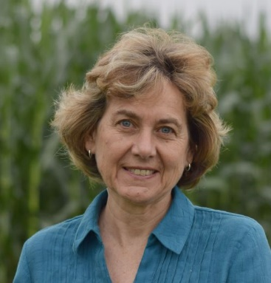
  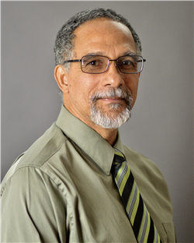 | Does drainage water management affect soil properties?  Richard is increasing the efficiency of drainage-related best management practices and developing protocols for their design. He develops techniques to simplify the extraction of elevation data from pulsed laser system (LiDAR) images, and creates rainfall harvesting systems to extend cropping into the dry season in Sierra Leone. He is currently an Associate Professor in the Department of Agricultural and Biological Engineering at the University of Illinois Urbana-Champaign. rcooke@illinois.edu
  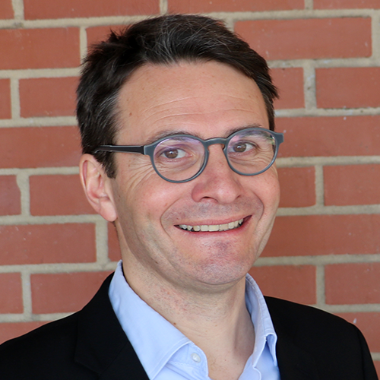 | Drying and wetting cycles of normally wet soil impact soil respiration and health.  Francois is an Associate Professor and University Faculty Scholar of Hydrology and Ecological Engineering at NC State. He directs the Biogeochemistry and Ecological Engineering Water lab, where he works to improve the treatment efficiencies of streams, wetlands, soils or woodchip bioreactors. birgand@ncsu.edu
  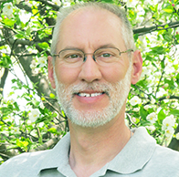 | Drainage requirements to maintain soil health.  Jeff is a Professor in the Department of Soil, Water, and Climate at the University of Minnesota. His research is focused in two areas: Drainage Water Management practices and Nutrient Management practices. He directs a field-based research program aimed at developing integrated water and nutrient management solutions for crop and livestock producers that reduces off-site nutrient mobility and improves water and nutrient use efficiency and crop yield. jstrock@umn.edu

